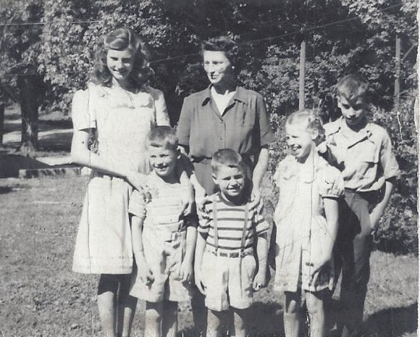

Lois, Nelson, Mary, John, Mary Jo, Philip Wolfe – 1946

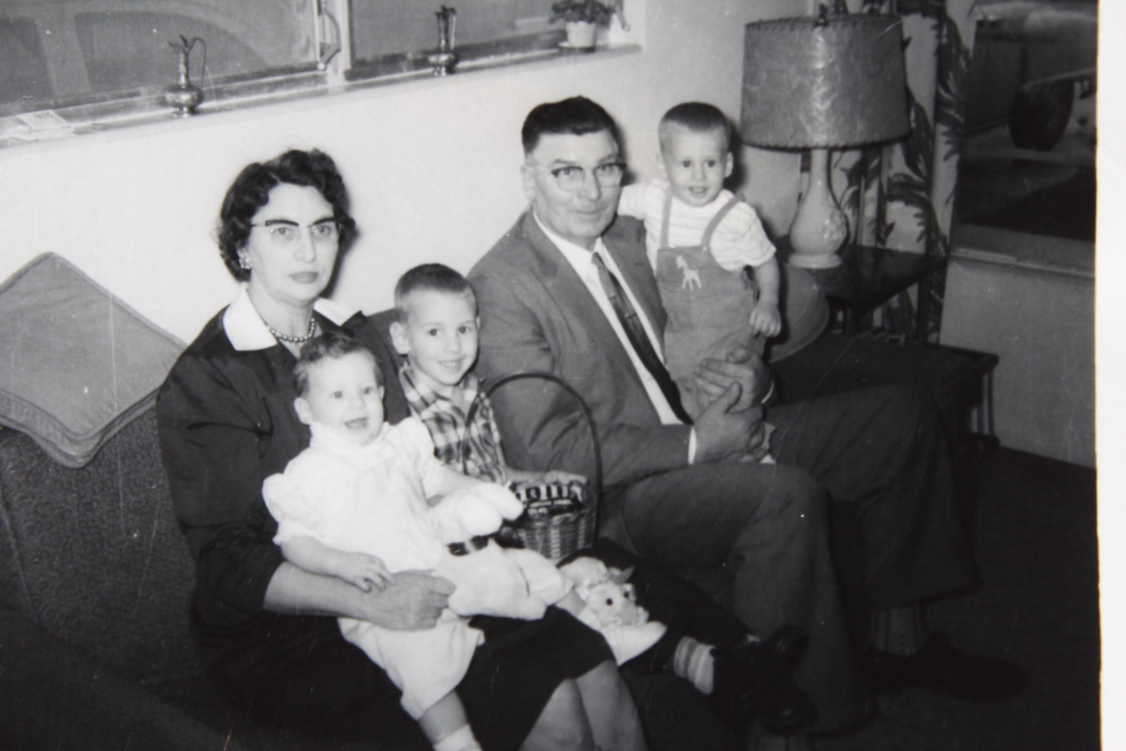

(l-r) Mary Wolfe holding Pamela Harrington, Daniel Harrington,

Russell Wolfe holding Gregory Harrington – 1959